KV THIRUVANNAMALAI

AISSCE - CBSE RESULTS:: MAY 2019

**CLASS : XII – 100%**

**CLASS : X – 100%**

**OUR TOPPERS ARE::**

*CLASS-XII SCIENCE STREAM -- 96% CLASS –X -- 89%*

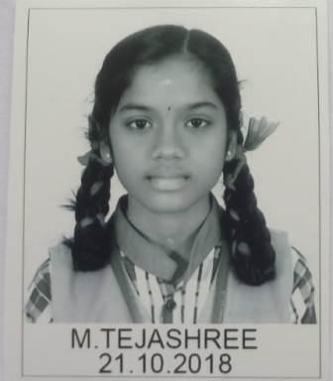

***CONGRATULATIONS TO ALL TEACHERS, STUDENTS AND STAFF MEMBERS***

**PRINCIPAL**